Name: Ritika Mohan
Prn: 23070521183
Semester: 5th C (C1)
Aim: Web Storage and State Management:
Use localStorage and sessionStorage to persist data across page reloads. Create a theme switcher or preference saver that remembers settings.
Output:
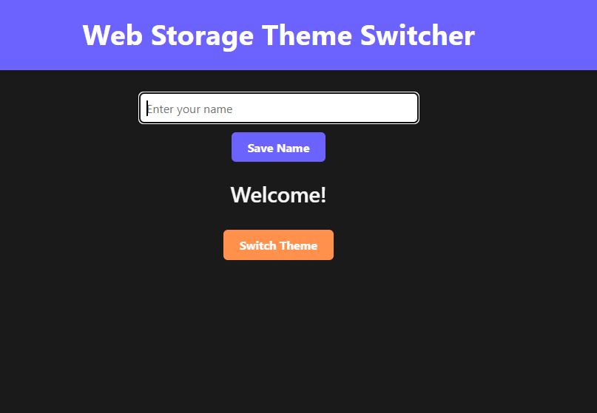
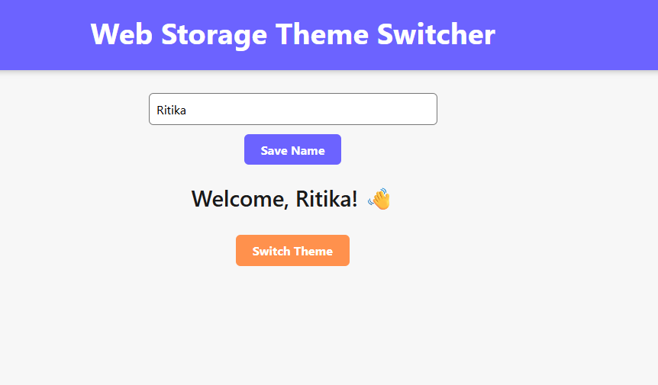
Conclusion: Hence created a theme switcher or preference saver that remembers settings.

